STAD BRUSSEL
departement STEDENBOUW – STADSVERNIEUWINGSCEL
Duurzaam Wijkcontract De MAROLLEn

Bijlage 1 aan het reglement : perimeter van het

Duurzaam Wijkcontract De Marollen

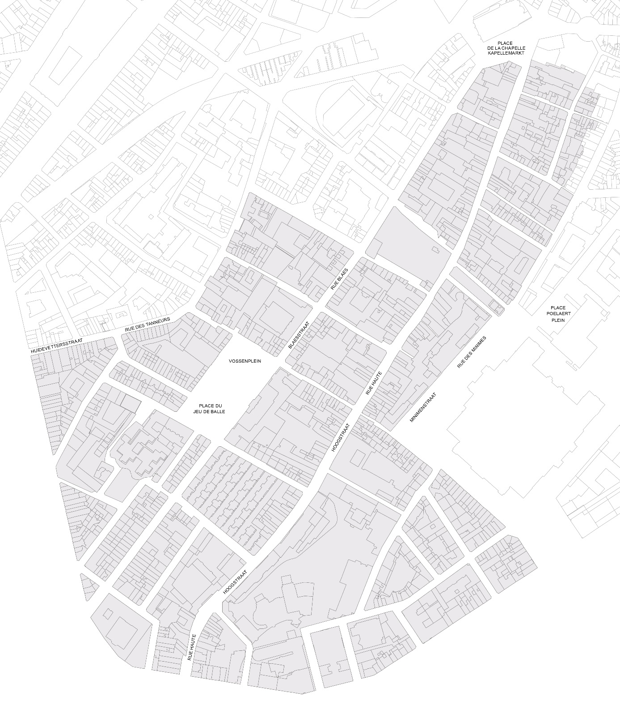

Bijlage 2 aan het reglement : kandidaturenformulier
Naam van het initiatief:
………………………………………………………………………………………………………………………………………………………………….
IDENTIFICATIE VAN DE VERANTWOORDELIJKE(N) VAN HET INITIATIEF:

Naam van de verantwoordelijke(n) :
…………………………………………………………………………………………………………………………………………………………………………………………

…………………………………………………………………………………………………………………………………………………………………………………………

…………………………………………………………………………………………………………………………………………………………………………………………

………………………………………………………………………………………………………………………………………………………………………………………..
(Desgevallend), Naam en voornaam van de hoofdverantwoordelijke : ………………………………………..…………………..…………………..
(Desgevallend), Naam en voornaam van de contactpersoon : ………………………………………………………………..…………………………….

Categorie :
Inwoner(s) Vzw Feitelijke vereniging Instelling/Organisatie

Andere: ………………………………………………;
- Adres : ……………………………………………………………………………………..……………………………………………………………………………

- Gemeente ………………………………………………………………………………………………………….……………PC ……………………
- E-mail : ……………………………………………………………………………………………………………………………………..…………………………..
- Tel./gsm : ………………………………………………………………………………………………………………………………..…………………………….

Voor de natuurlijke personen die zich kandidaat stellen :
Naam en voornaam van de bankrekeninghouder :
………………………………………………………………………………………………………………………………………………………………..………………………
Rijksregisternummer:
………………………………………………………………………………………………………………………………………………………………………………………..

Bankrekeningnummer (IBAN):
………………………………………………………………………………………………………………………………………………………………..…………………………
Toe te voegen bijlagen:
- een fotokopie van de identiteitskaart (R/V)
- een fotokopie van de bankkaart (R/V)

Indien de verantwoordelijke van het initiatief niet in de perimeter van het DWC De Marollen gevestigd is, motivatie van zijn belangstelling voor de wijk toelichten :
………………………………………………………………………………………………………………………………………………………………………………………………
………………………………………………………………………………………………………………………………………………………………………………………………
………………………………………………………………………………………………………………………………………………………………………………………………
………………………………………………………………………………………………………………………………………………………………………………………………

Voor de VZW en de verenigingen :
Naam en voornaam van de bankrekeninghouder van de vereniging :
………………………………………………………………………………………………………………………………………………………………..……………………………

Identificatienummer van de vereniging toevoegen(ondernemingsnummer, 9 cijfers) :
………………………………………………………………………………………………………………………………………………………………..……………………………

Bankrekeningnummer (IBAN):
………………………………………………………………………………………………………………………………………………………………..……………………………TToe te voegen bijlagen:
- attest identificatie rekening (RIB) te verkrijgen bij de bank;
- fotokopie van de laatste statuten van de vereniging, gepubliceerd in het Belgisch Staatsblad.

Eventuele partners van het project
Gegevens (Naam, adres, email) | Betrokkenheid
…………………………………………………………………………………………………………..  …………………………………………………………………………………………………………..  ………………………………………………………………………………………………………….. | …………………………………………………………………………  …………………………………………………………………………  …………………………………………………………………………
…………………………………………………………………………………………………………..  …………………………………………………………………………………………………………..  ………………………………………………………………………………………………………….. | …………………………………………………………………………  …………………………………………………………………………  …………………………………………………………………………
…………………………………………………………………………………………………………..  …………………………………………………………………………………………………………..  ………………………………………………………………………………………………………….. | …………………………………………………………………………  …………………………………………………………………………  …………………………………………………………………………
…………………………………………………………………………………………………………..  …………………………………………………………………………………………………………..  ………………………………………………………………………………………………………….. | …………………………………………………………………………  …………………………………………………………………………  …………………………………………………………………………
…………………………………………………………………………………………………………..  …………………………………………………………………………………………………………..  ………………………………………………………………………………………………………….. | …………………………………………………………………………  …………………………………………………………………………  …………………………………………………………………………
…………………………………………………………………………………………………………..  …………………………………………………………………………………………………………..  ………………………………………………………………………………………………………….. | …………………………………………………………………………  …………………………………………………………………………  …………………………………………………………………………
…………………………………………………………………………………………………………..  …………………………………………………………………………………………………………..  ………………………………………………………………………………………………………….. | …………………………………………………………………………  …………………………………………………………………………  …………………………………………………………………………

Omschrijving van het initiatief
Algemene omschrijving (maximum 1 pagina) :
……………………………………………………………………………………………………………………………………………………………………………………………………………………………………………………………………………………………………………………………………………………………………………………………………………………………………………………………………………………………………………………………………………………………………………………………………………………………………………………………………………………………………………………………………………………………………………………………………………………………………………………………………………………………………………………………………………………………………………………………………………………………………………………………………………………………………………………………………………………………………………………………………………………………………………………………………………………………………………………………………………………………………………………………………………………………………………………………………………………………………………………………………………………………………………………………………………………………………………………………………………………………………………………………………………………………………………………………………………………………………………………………………………………………………………………………………………………………………………………………………………………………………………………………………………………………………………………………………………………………………………………………………………………………………………………………………………………………………………………………………………………………………………………………………………………………………………………………………………………………………………………………………………………………………………………………………………………………………………………………………………………………………………………………………………………………………………………………………………………………………………………………………………………………………………………………………………………………………………………………………………………………………………………………………………………………………………………………………………………………………………………………………………………………………………………………………………………………………………………………………………………………………………………………………………………………………………………………………………………………………………………………………………………………………………………………………………………………………………………………………………………………………………………………………………………………………………………………………………………………………………………………………………………………………………………………………………………………………………………………………………………………………………………………………………………………………………………………………………………………………………………………………………………………………………………………………………………………………………………………………………………………………………………………………………………………………………………………………………………………………………………………………………………………………………………………………………………………………………………………………………………………………………………………………………………………………………………………………………………………………………………………………………………………………………………………………………………………………………………………………………………………………………………………………………………………………………………………………………………………………………………………… Lokalisatie van het initiatief (maximum 1/2 pagina) :
………………………………………………………………………………………………………………………………………………………………………………………………………………………………………………………………………………………………………………………………………………………………………………………………………………………………………………………………………………………………………………………………………………………………………………………………………………………………………………………………………………………………………………………………………………………………………………………………………………………………………………………………………………………………………………………………………………………………………………………………………………………………………………………………………………………………………………………………………………………………………………………………………………………………………………………………………………………………………………………………………………………………………………………………………………………………………………………………………………………………………………………………………………………………………………………………………………………………………………………………………………………………………………………………………………………………………………………………………………………………………………………………………………………………………………………………………………………………………………………………………………………………………………………………………………………………………………………………………………………………………………………………………………………………………………………………………………………………………………………………………………………………………………………………………………………………………………………………………………………………………………………………………………………………………………………………………………………………………………………………………………………………………………………………………………………………………………………………………………………………………………………………………………………………………………………………………………………………………………………………………………………………………………………………………………………………………………………………………………………………………………………………………………………………………………………………………………………………………………………………………………………………………………………………………………………………………………………………………………………………………………………………………………………………………………………………………………………………………………………………………………………………………………………………………………………………………………………………………………………………………………………………………………………………………………………………………………………………………………………………………………………………………………………………………………………………………………………………………………………………………………………………………………………………………………………………………………………………………………………………………………………………………………………………
Doelstellingen (overeenstemming met één of meerdere doelstellingen hernomen in artikel 1 (maximum 1/2 pagina) :
………………………………………………………………………………………………………………………………………………………………………………………………………………………………………………………………………………………………………………………………………………………………………………………………………………………………………………………………………………………………………………………………………………………………………………………………………………………………………………………………………………………………………………………………………………………………………………………………………………………………………………………………………………………………………………………………………………………………………………………………………………………………………………………………………………………………………………………………………………………………………………………………………………………………………………………………………………………………………………………………………………………………………………………………………………………………………………………………………………………………………………………………………………………………………………………………………………………………………………………………………………………………………………………………………………………………………………………………………………………………………………………………………………………………………………………………………………………………………………………………………………………………………………………………………………………………………………………………………………………………………………………………………………………………………………………………………………………………………………………………………………………………………………………………………………………………………………………………………………………………………………………………………………………………………………………………………………………………………………………………………………………………………………………………………………………………………………………………………………………………………………………………………………………………………………………………………………………………………………………………………………………………………………………………………………………………………………………………………………………………………………………………………………………………………………………………………………………………………………………………………………………………………………………………………………………………………………………………………………………………………………………………………………………………………………………………………………………………………………………………………………………………………………………………………………………………………………………………………………………………………………………………………………………………………………………………………………………………………………………………………………………………………………………………………………………………………………………………………………………………………………………………………………………………………………………………………………………………………………………………………………………………………………………………………………………………………………………………………………………………………………………………………………………………………………………………………………………………………………………………………………………………………………………………………………………………………………………………………………………………………………………………………………………………………………………………………………………………………………………………………………………………………………………………………………………………………………………………………………………………………………………………………………………………………………………………………………………………………………………………………………………………………………………………
Verwachte resultaten van het initiatief (maximum 1/2 pagina) :
………………………………………………………………………………………………………………………………………………………………………………………………………………………………………………………………………………………………………………………………………………………………………………………………………………………………………………………………………………………………………………………………………………………………………………………………………………………………………………………………………………………………………………………………………………………………………………………………………………………………………………………………………………………………………………………………………………………………………………………………………………………………………………………………………………………………………………………………………………………………………………………………………………………………………………………………………………………………………………………………………………………………………………………………………………………………………………………………………………………………………………………………………………………………………………………………………………………………………………………………………………………………………………………………………………………………………………………………………………………………………………………………………………………………………………………………………………………………………………………………………………………………………………………………………………………………………………………………………………………………………………………………………………………………………………………………………………………………………………………………………………………………………………………………………………………………………………………………………………………………………………………………………………………………………………………………………………………………………………………………………………………………………………………………………………………………………………………………………………………………………………………………………………………………………………………………………………………………………………………………………………………………………………………………………………………………………………………………………………………………………………………………………………………………………………………………………………………………………………………………………………………………………………………………………………………………………………………………………………………………………………………………………………………………………………………………………………………………………………………………………………………………………………………………………………………………………………………………………………………………………………………………………………………………………………………………………………………………………………………………………………………………………………………………………………………………………………………………………………………………………………………………………………………………………………………………………………………………………………………………………………………………………………………………
Beoogd/betrokken publiek bij het initiatief en ter beschikking gestelde middelen om dit publiek te bereiken (maximum 1/2 pagina) : :
………………………………………………………………………………………………………………………………………………………………………………………………………………………………………………………………………………………………………………………………………………………………………………………………………………………………………………………………………………………………………………………………………………………………………………………………………………………………………………………………………………………………………………………………………………………………………………………………………………………………………………………………………………………………………………………………………………………………………………………………………………………………………………………………………………………………………………………………………………………………………………………………………………………………………………………………………………………………………………………………………………………………………………………………………………………………………………………………………………………………………………………………………………………………………………………………………………………………………………………………………………………………………………………………………………………………………………………………………………………………………………………………………………………………………………………………………………………………………………………………………………………………………………………………………………………………………………………………………………………………………………………………………………………………………………………………………………………………………………………………………………………………………………………………………………………………………………………………………………………………………………………………………………………………………………………………………………………………………………………………………………………………………………………………………………………………………………………………………………………………………………………………………………………………………………………………………………………………………………………………………………………………………………………………………………………………………………………………………………………………………………………………………………………………………………………………………………………………………………………………………………………………………………………………………………………………………………………………………………………………………………………………………………………………………………………………………………………………………………………………………………………………………………………………………………………………………………………………………………………………………………………………………………………………………………………………………………………………………………………………………………………………………………………………………………………………………………………………………………………………………………………………………………………………………………………………………………………………………………………………………………………………………………………………………………………………………………………………………………………………………………………………………………………………………………………………………………………………………………………………………………………………………………………………………………………………………………………………………………………………………………………………………………………………………………………………………………………………………………………………………………………………………………………………………………………………………………………………………………………………………………………………………………………………………………………………………………………………………………………………………………………………………………………………
Omschrijving van de toepasselijkheid en van de impact van het initiatief op de perimeter van het DWC De Marollen (maximum 1/2 pagina) :
………………………………………………………………………………………………………………………………………………………………………………………………………………………………………………………………………………………………………………………………………………………………………………………………………………………………………………………………………………………………………………………………………………………………………………………………………………………………………………………………………………………………………………………………………………………………………………………………………………………………………………………………………………………………………………………………………………………………………………………………………………………………………………………………………………………………………………………………………………………………………………………………………………………………………………………………………………………………………………………………………………………………………………………………………………………………………………………………………………………………………………………………………………………………………………………………………………………………………………………………………………………………………………………………………………………………………………………………………………………………………………………………………………………………………………………………………………………………………………………………………………………………………………………………………………………………………………………………………………………………………………………………………………………………………………………………………………………………………………………………………………………………………………………………………………………………………………………………………………………………………………………………………………………………………………………………………………………………………………………………………………………………………………………………………………………………………………………………………………………………………………………………………………………………………………………………………………………………………………………………………………………………………………………………………………………………………………………………………………………………………………………………………………………………………………………………………………………………………………………………………………………………………………………………………………………………………………………………………………………………………………………………………………………………………………………………………………………………………………………………………………………………………………………………………………………………………………………………………………………………………………………………………………………………………………………………………………………………………………………………………………………………………………………………………………………………………………………………………………………………………………………………

Planning van het initiatief
STAPPEN | UITVOERINGEN | VOORZIENE DATUMS | PLAATS
………………………………………….  …………………………………………. | ………………………………………….  …………………………………………. | ………………………………………….  …………………………………………. | ………………………………………….  ………………………………………….
………………………………………….  …………………………………………. | ………………………………………….  …………………………………………. | ………………………………………….  …………………………………………. | ………………………………………….  ………………………………………….
………………………………………….  …………………………………………. | ………………………………………….  …………………………………………. | ………………………………………….  …………………………………………. | ………………………………………….  ………………………………………….
………………………………………….  …………………………………………. | ………………………………………….  …………………………………………. | ………………………………………….  …………………………………………. | ………………………………………….  ………………………………………….
………………………………………….  …………………………………………. | ………………………………………….  …………………………………………. | ………………………………………….  …………………………………………. | ………………………………………….  ………………………………………….
………………………………………….  …………………………………………. | ………………………………………….  …………………………………………. | ………………………………………….  …………………………………………. | ………………………………………….  ………………………………………….
………………………………………….  …………………………………………. | ………………………………………….  …………………………………………. | ………………………………………….  …………………………………………. | ………………………………………….  ………………………………………….

Budget van het initiatief
Totaal budget nodig voor de uitvoering van het initiatief : ………………………………………………………………………………………………………
Gevraagd budget in het kader van onderhavige initiatievenoproep : ………………………………………………………………………………………
Andere bronnen van inkomsten die beschikbaar zijn voor dit project. Zo ja, dewelke ? ………………………………………...................
………………………………………………………………………………………………………………………………………………………………………………………………..
Detailleer de voorziene uitgaven voor de uitvoering van uw project (voorbeelden : voeding, huur of aankoop van materieel, artistieke prestaties, verzekeringen, …) :
Type uitgave | Bedrag
Ex : huur van feesttent | 300,00 EUR
TOTAAL

(de tabel van onderhavig document herneemt uitsluitend bedragen die dienen als voorbeeld)
Door onderhavig formulier te ondertekenen, verklaart de initiatiefverantwoordelijke op eer dat zijn begroting eerlijk en realistisch werd opgesteld.
Hij erkent eveneens dat elke financiële bijdrage toegekend door de autoriteiten dient besteed te worden in het kader van de doelstellingen waarvoor deze werden toegekend.

Ondertekening en verbintenis van de initiatiefverantwoordelijke(n)
Bij deze verklaart(verklaren) de initiatiefverantwoordelijke(n) kennis genomen te hebben van het reglement van de initiatievenoproep en verbindt(verbinden) hij(zij) zich ingeval van selectie deze volledig te respecteren. Het reglement maakt integraal deel uit van kandidaturenformulier. Elke pagina dient eveneens ondertekend te worden door de initiatiefverantwoordelijke(n).
Opgemaakt te ......................................................... op .........................................................
Naam,  ......................................................... | Voornaam,  ......................................................... | Handtekening,  .........................................................

